CS 340 README Template

Use this template to complete your README file. When completing the template, keep the headings as they are so that your document has a clear organization. Remove the italicized prompt text after you have completed each section for a polished final document.

About the Project/Project Title
This project is a Python module for managing animal shelter data. It allows users to create new records and read existing records from a database.

Motivation
The motivation behind this project was to make it easier to manage shelter data by providing a simple Python module that allows the user to create, read, update, and delete documents in the MongoDB environment.

Getting Started
The first step in the project is to import the Austin Animal Center (AAC) Outcomes data set into MongoDB and then create a user account.
- Open up a terminal session and navigate to the datasets folder.
- Upload the CSV file “aac_shelter_outcomes.csv” into MongoDB using mongoimport:
mongoimport --db aac --collection animals --type csv --headerline --file datasets/aac_shelter_outcomes.csv
- Open the Mongo shell using mongosh and create a user account with read/write access:
use admin
db.createUser({user: "aacuser", pwd: passwordPrompt(), roles: [{role: "readWrite", db: "aac"}]})

Installation
To use this Python module, you will need the following tools:
- Python 3.10+ - Required to run the module. Install from python.org.
- MongoDB – To access the database. Install from mongodb.com.

Usage
Make sure you configure the MongoDB connection and user account credentials in the Python file.
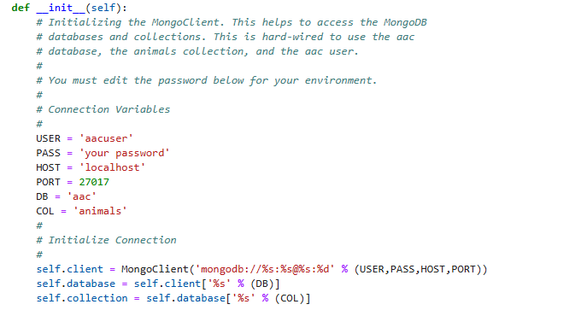

Importing the CRUD Module: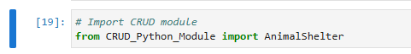

Instantiating an instance of the class:


Testing the create function by creating a new test record in the database:
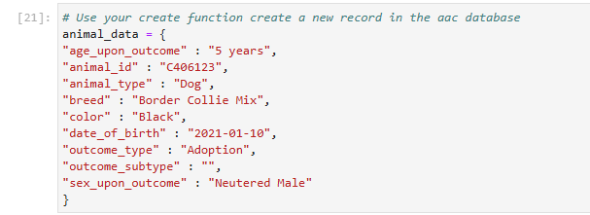

Inserting the document into MongoDB:
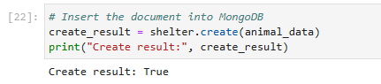
Test the read function:
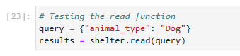
Display results:
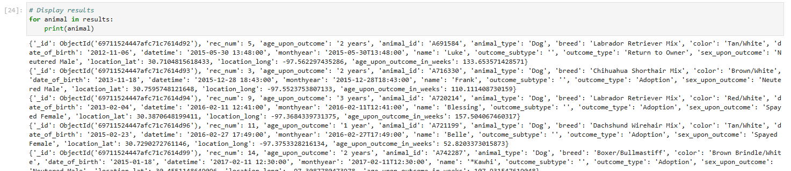

Contact
Your name: Corey Gaspar

